The Spy Who Loved Me
When the 10th James Bond film The Spy Who Loved Me had its premier in London on the 7th July 1977 the future of the franchise depended on its box office success. It had been three years since the The Man With The Golden Gun (1974) had largely failed to impress critics and resulted (for a Bond movie) in only modest returns. In the meantime, a host of other problems had delayed production. Albert (Chubby) Broccoli – now without his long-time co-producer Harry Saltzman, had made the decision to throw everything at the screen that a £13.5 million budget would allow. And that was quite a lot: a strong script; a Roger Moore James Bond that seemed, after two goes at the role, truly distinct from previous incarnations (Sean Connery and George Lazenby), spectacular stunts, exotic locations, jaw-dropping sets and carefully crafted set-piece battles, trademark glamour and excitement by the submarine-full, and a 2.35:1 aspect ratio that meant the film looked big on the screen: a film to be seen in the cinema!
As well as enabling you to explore some of the background to the film, both specific to its making and more broadly in terms of the cultural context, this set of resources will also look at the conventions of the James Bond franchise and the way The Spy Who Loved Me borrowed from previous films in the series to ensure its popularity.
But first, its promotion and distribution to which some $7 million was devoted – an enormous sum.
The Poster And The Trailer
‘It’s the biggest. The best. It’s Bond. And beyond!’
This is your chance to analyse two of the key elements in the promotion of any film (the methods by which the potential audience is alerted to a film’s release and ‘educated’ as to its likely content and pleasures): the poster and the trailer.
Do you feel the poster lives up to the ‘strapline’ at the top? Note the typesetting of
b-e-y-o-n-d – why the dashes between each letter?
Note the central figures – what does that suggest about the ‘story’ and its principal characters? Note that while Roger Moore’s Bond holds a gun, while Barbara Bach’s Major Anya Amasova (Triple X) toys with her necklace and her
dress is revealing – what do these elements suggest about their roles despite the film’s conceit that as spies with licenses to kill, they were on an equivalent footing.
Both the poster and the trailer are explicit in suggesting the variety of thrills and spills the film will contain. Ideally, before watching the film study the poster as a kind of map to The Spy Who Loved Me – what clues or promises does it contain as to the kinds of people, places and experiences we will have.
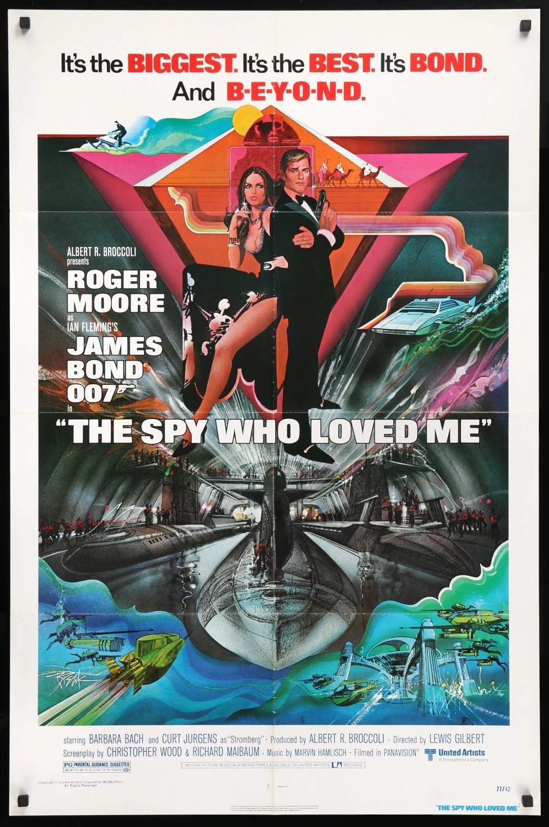
(US one-sheet poster for the 1977 release of The Spy Who Loved Me. Designer: Bob Peak.)
The Spy Who Loved Me (1977) Official Trailer - Roger Moore James Bond Movie HD - YouTube
Now watch the trailer and try to work out how it tries to ‘place’ the film in terms of its genre and its possible audience – age/gender. A James Bond film was and (amazingly) remains a major cultural event - the perfect ‘date’ movie; the ideal ‘family-treat’ movie.

There are lots of ways to persuade people to do or buy things. Study the following list and discuss which of the ‘hooks’ are employed in this original Spy Who Loved Me trailer: more than one applies.

- Anger
- Familiarity – a tried and tested formula or franchise; the next part of a story or series (franchise).
- The desire to be diverted or amused – escapism. The desire to explore a fantastic world or be witness to exciting events.
- Fear of missing out (FOMO)
- Watch it on a big screen in a cinema rather than via a streaming service
- Authenticity
- By-passes or pushes the rules on censorship or public taste
- Zeitgeist – what was happening in the world at the time/what people were concerned with at the time.
- At long last….
- Exotic locations or people
- Historic events brought to life
- A story experienced in a different context brought to life on the screen (a novel; a TV-show; a video-game; even a theme-park ride)
- Curiosity
- Endurance – this film will really put you through something.
- Empathy – understanding things from a very different point-of-view
- Romance/Love
- The sexual attractiveness of a male or female star
- The acting ability of a male or female lead
- The desire to be horrified or shocked
- Education – you’ll learn something by seeing this film.
- Soundtrack/Music
- If this is the trailer, what will the film be like?

Anything else?

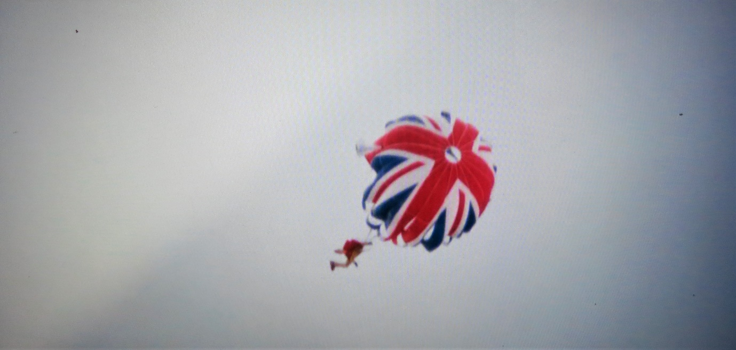
The Story Shape
For all the spectacular settings, stunts and gadgets, James Bond films are generally pretty simple tales. Your task is to marry up these basic elements to the plot of The Spy Who Loved Me:
A settled community. It does not have to be a happy community but it needs to be in some sort of balance.
Something disrupts the equilibrium of that community.
A hero is found
The hero is asked to go on a quest to rescue someone or something.
The hero faces a number of gatekeepers who delay him/her. These must be by-passed.
The hero faces a number of out-and-out antagonists, keen to defeat and kill him/her.
The hero faces these threats and overcomes them.
There may be a period in which the hero has to recover from a set-back or temporary defeat. (S)He returns stronger than ever having licked his wounds.
There is a spectacular final confrontation with the main enemy.
The hero escapes (typically having rescued ‘the princess’).
The hero is rewarded.
Happy ever after – or in a James Bond film, the promise of further thrills to come. Other loose ends might remain. Also try to work out where you would place Agent Triple X’s parallel aim to have revenge on James Bond. How is that resolved?
James Bond Motifs
Part of the pleasure, a large part, of a Bond movie, is that it is so familiar. From the gun barrel opening, and the well-known Bond musical theme, one can expect a whole series of tried and tested elements. There is a detailed breakdown of these motifs at: Motifs in the James Bond film series - Wikipedia. Your task is work your way through the list provided at this site and note which of them feature in The Spy Who Loved Me. It was the success and scale of many of these familiar ‘tropes’ that made The Spy Who Loved Me such a s success.
Having done this consider the following motifs in particular:
- The Bond Women and Sexual Politics in The Spy Who Loved Me.
Much is made of the fact that James Bond faced a female rival and fellow protagonist in the film – one who, it seems, poses a direct threat to our hero. Two if you could the Caroline Munroe ‘Naomi’ character in her helicopter. The late 70s was the period when feminism was starting (slowly) to have an impact on society but what do you make of the sexual politics of the film? Is there a great deal in the movie that suggests women are still play-things and passive? Is there any evidence of out-and-out misogyny and violence against women? (Note: this was the first film in which Bond actually kills a female character.)

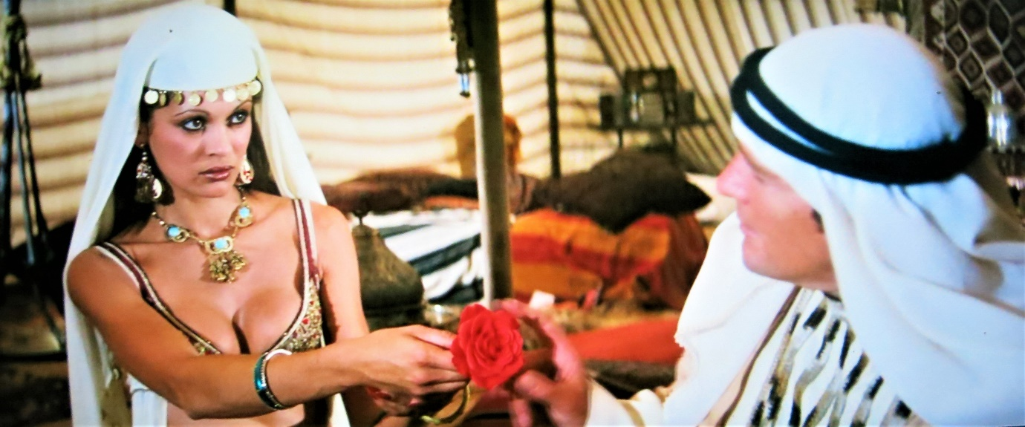

- The Baddie.
‘Farewell, Mr Bond – that word has, I must admit, a welcome ring of permanency about it.’
Stromberg is in many ways an archetypical Bond antagonist. But what elements that make up these kinds of characters can you spot in the film. (Clue: a key one is that the baddie should have a physical characteristic that marks him out. Stromberg has one, but blink and you’ll miss it – look out for any shots of his hands in the first scene in which he appears.
